

**Department of Computer Science and Engineering**

**COURSE CODE**  : CSE 212

**COURSE TITLE**  : Database Systems Lab

Name of Project**:** Company Management System

**Date of Submission** : 04.02.2020

**Submitted to**

**Nadeem Ahmed**

Assistant professor, Dept. of CSE

**Submitted by**

Fariha Sultana Rini

**ID:** 18101074

**Section**: B1

**Department of CSE**

**INDEX**

Page no: 2

|  |  |  |
| --- | --- | --- |
| Serial No | Subject | Page no |
| 01 | Project Scenario | 03-04 |
| 02 | ER Diagram | 05 |
| 03 | Schema Diagram | 06 |
| 04 | Create Database &Table | 07-08 |
| 05 | Insert Data | 09-11 |
| 06 | Results | 12-14 |
| 07 | Query |  |
|  |  |  |

Page no: 3

PROJECT SENARIO

We all works in any company. There are many department, employee in a company. Every employee works on a project under a department in a company. So a company needs a proper management system to maintain its works properly. So, we are creating a **company management system** to show how a company works with a help of er diagram & schema diagram.

In our entity relation diagram, we show how a company works.

**Entities & their relationship:**

We have many entities for the management .For example employee, department and project &they have many relation.

* Many employee works for a certain department and all department managed by a supervisor. So according to **works for relation** employee & department has **many to many relation.**
* In a company many employee works on a project .In the other hand an employee can works on many project. So according to **works on** **relation** employee & project has **many to many relation.**
* Normally a department controls many project .So they have **one to one relation** according to **controls relation.**

According to er diagram we form a schema diagram for the system-

Page no: 4

* **Department** (DepartmentID, Dept_Name, LocationID, EmployeeNo) table has all information about a department.
* Through **employee** (FirstName, Initials, LastName, designation, salary, Street, Postal Code, DepartmentID) table we can know all employee information who work in a company.
* The **project** (ProjectID, Project_name, DepartmentId) table can give us all about a project.

According to relation many table formed like **works on**, **works for** & **postal code**.

This is our overall er & schema diagram for a company management system.

Page no: 5

**ER Diagram**

E

EER

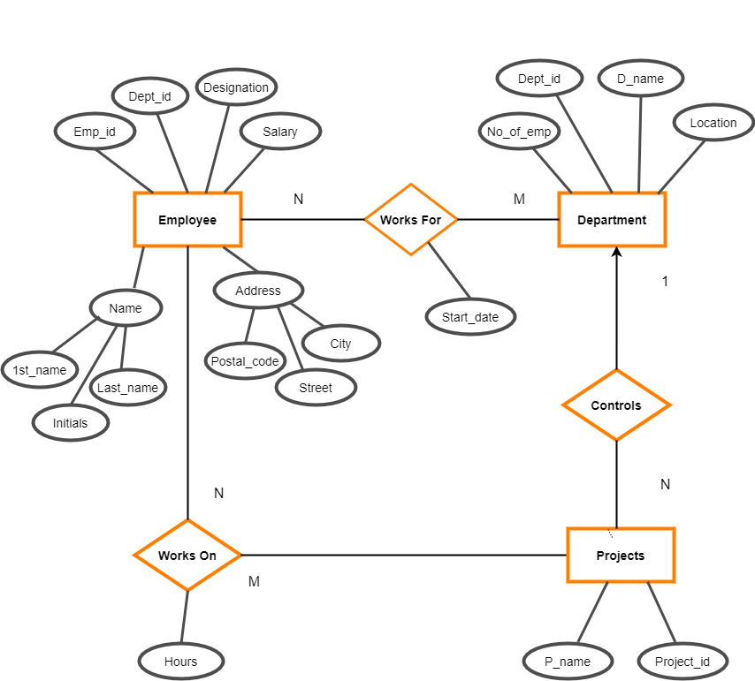

Page no: 6

**Schema Diagram**

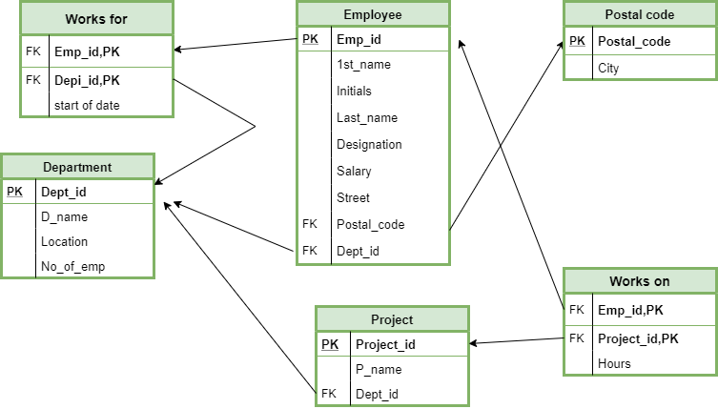

Page no: 7

**Create database & table:**

create database company_Management

use company_Management

GO

**Create table Department**

(

DepartmentID varchar(50) primary key,

Dept_Name varchar(50),

LocationID varchar(50),

EmployeeNo int,

);

**create table PostalCode**

(

PostalCode varchar(50) primary key,

city varchar(50)

);

**create table Employee**

(

EmployeeID varchar(50) primary key,

FirstName varchar(50),

Initials varchar(50),

LastName varchar(50),

designation varchar(50),

salary money,

Street varchar(50),

PostalCode varchar(50),

DepartmentID varchar(50),

foreign key(PostalCode) references PostalCode(PostalCode),

foreign key(DepartmentID) references Department(DepartmentID)

);

Page no: 8

**create table project**

(

ProjectID varchar (50) primary key,

Project_name varchar(50),

DepartmentId varchar(50),

foreign key(DepartmentID) references Department(DepartmentID )

);

**create table workson**

(

EmployeeID varchar(50),

ProjectID varchar(50),

hours varchar(50),

foreign key(EmployeeID) references Employee(EmployeeID),

foreign key(ProjectID) references Project(ProjectID ),

primary key(EmployeeID,ProjectID)

);

**create table worksfor**

(

EmployeeID varchar(50),

DepartmentId varchar(50),

startDate varchar(50),

foreign key(EmployeeID) references Employee(EmployeeID),

foreign key(DepartmentId ) references Department(DepartmentId ),

primary key(EmployeeID,DepartmentId)

);

**DATA INSERT:**

Page no: 9

**insert into Department**

**values**

('1&2-PD' , 'Production', 'YUKO LEATHER GOODS LTD' , 200),

('3-R&D', 'Research and Development', 'YUKO LEATHER GOODS LTD', 80),

('4-M&S', 'Marketing', 'YUKO LEATHER GOODS LTD', 80),

('5-HR','Human Resources Management','YUKO LEATHER GOODS LTD', 70),

('6-AF','Accouting & Finance','YUKO LEATHER GOODS LTD', 60);

**insert into PostalCode**

**values**

('1206','Dhaka'),

('1209','Dhaka'),

('1213', 'Dhaka'),

('1232','Dhaka'),

('1310','Dhaka'),

('1219','Dhaka'),

('1211','Dhaka'),

('1207','Dhaka'),

('1225','Dhaka'),

('1222','Dhaka'),

('1223','Dhaka'),

('1212','Dhaka'),

('4321','Chittagong'),

('4211','Chittagong'),

('3543','Chittagong'),

('3831','Chittagong'),

('7210','Khulna'),

('7032','Khulna'),

('7222','Khulna'),

('7620','Khulna'),

('6422','Rajshahi'),

('6650','Rajshahi'),

('6680','Rajshahi'),

('6330','Rajshahi');

Page no: 10

**insert into employee**

**values**

('P1', 'Anisul', 'AI' , 'Islam', 'Production Manager', 70000, 'Dhanmondi-15','1209' ,'1&2-PD'),

('P2', 'Ruhul', 'RA','Alam', 'Assistant Plant Manager',45000, 'Dhanmondi-07','1209', '1&2-PD'),

('P3', 'Shariar', 'SI', 'Istam','Production engineers',55000, 'Gulshan-01','1213', '1&2-PD'),

('P4','Anisur','AR','Rahman','Production engineer',55000,'Banani-11','1219','1&2-PD'),

('P5','Lara','LH','Hasan','Worker',20000,'Bangra-11','3543','1&2-PD'),

('P6','Tonni','TP','Paul','Worker',20000,'Arpara-11','7620','1&2-PD'),

('P7','Mariam','MM','Mim','Worker',20000,'Gandaria-33','1206','1&2-PD'),

('P8','Friha','FR','Rini','Worker',20000,'Amin road-12','4211','1&2-PD'),

('P9','Monisha','MR','Roy','Worker',20000,'Arpara-08','7620','1&2-PD'),

('RD1','Afsana','AA','Ahmed', 'Scientist',100000, 'Gulsan-02','1310','3-R&D'),

('RD2','Kawser','KI','Islam','Scientist',100000,'Khilgaon-01','1213','3-R&D'),

('RD3','Saib','SA','Ali','Engineer',70000,'Rajshahi sadar-09','6650','3-R&D'),

('MS1','Hasan','HA','Ali','Coordinator',50000,'Alamdanga-11','7210','4-M&S'),

('MS2','Tonmoy','TR','Rahman','Sales & Marketing Executive',55000,'Amin road-12','4211','4-M&S'),

('MS3','Anika','AB','Binte','Senior Executive',65000,'Banwarinagar-04','6650','4-M&S'),

('HR1','Tonnima','TA','Akter','Officer',45000,'Abutorab-07','4321','5-HR'),

('HR2','Tuba','TM','Mullick','HR Executive',50000,'Andulbaria-07','7222','5-HR'),

('AF1','Yesmin','YS','Sarowar','Assistant Officer',50000,'Abdulpur-01','6422','6-AF'),

('AF2','Anik','AK','Khandokar','Regional Accountant',30000,'Alaiarpur-44','3831','6-AF'),

('AF3','Sreejoy','SH','Howlader','Senior Manager',60000,'Bholahat-33','6330','6-AF');

**insert into project**

**values**

( 'BG', 'Genuine Leather Bags', '3-R&D'),

('LW', 'Genuine Leather Wallets' , '3-R&D'),

('BT', 'Genuine Leather Belt', '3-R&D'),

('AS', 'Genuine Leather Accessories', '3-R&D'),

('JT','Genuine Leather Jacket' , '3-R&D');

**insert into worksfor**

Page no: 11

**Values**

('P1', '1&2-PD', '01-01-2015'),

('P2', '1&2-PD', '02-05-2012'),

('P3', '1&2-PD', '02-05-2012'),

('P4', '1&2-PD', '02-04-2010'),

('P5', '1&2-PD', '02-04-2010'),

('P6', '1&2-PD', '02-05-2010'),

('P7', '1&2-PD', '02-05-2010'),

('P8', '1&2-PD', '02-05-2010'),

('P9', '1&2-PD', '02-05-2010'),

('RD1', '3-R&D','03-01-2013'),

('RD2', '3-R&D','03-02-2013'),

('RD3', '3-R&D','03-01-2014'),

('MS1','4-M&S','01-01-2015'),

('MS2','4-M&S','01-02-2015'),

('MS3','4-M&S','01-01-2015'),

('HR1','5-HR','01-01-2013'),

('HR2','5-HR','01-01-2013'),

('AF1','6-AF','03-03-2012'),

('AF2','6-AF','03-03-2012'),

('AF3','6-AF','03-03-2012');

**insert into workson**

**values**

('P1','BG','360 hours'),

('P2','BG','360 hours'),

('P3','BG','360 hours'),

('P4','BG','360 hours'),

('RD1','BG','360 hours'),

('RD2','BG','360 hours'),

('RD3','BG','360 hours'),

('P1','LW','240 hours'),

('P2','LW','240 hours'),

('P3','LW','240 hours'),

('P4','LW','240 hours'),

('RD1','LW','240 hours'),

('RD2','LW','240 hours'),

('RD3','LW','3240 hours'),

('P1','JT','360 hours'),

('P2','JT','360 hours'),

('P3','JT','360 hours'),

('P4','JT','360 hours'),

('RD1','JT','360 hours'),

('RD2','JT','360 hours'),

('RD3','JT','360 hours');

**Select from table:**

Page no: 12

**select * from Department**

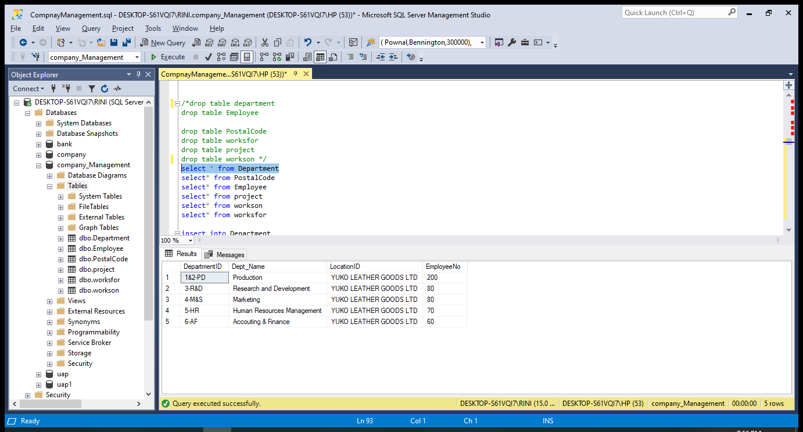

**select * fromPostalCode**

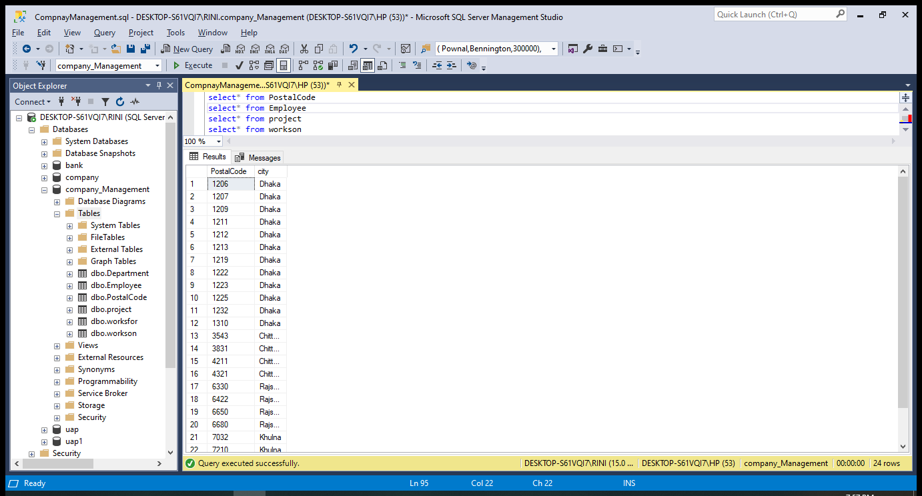

Page no:13 110

**select* from Employee**

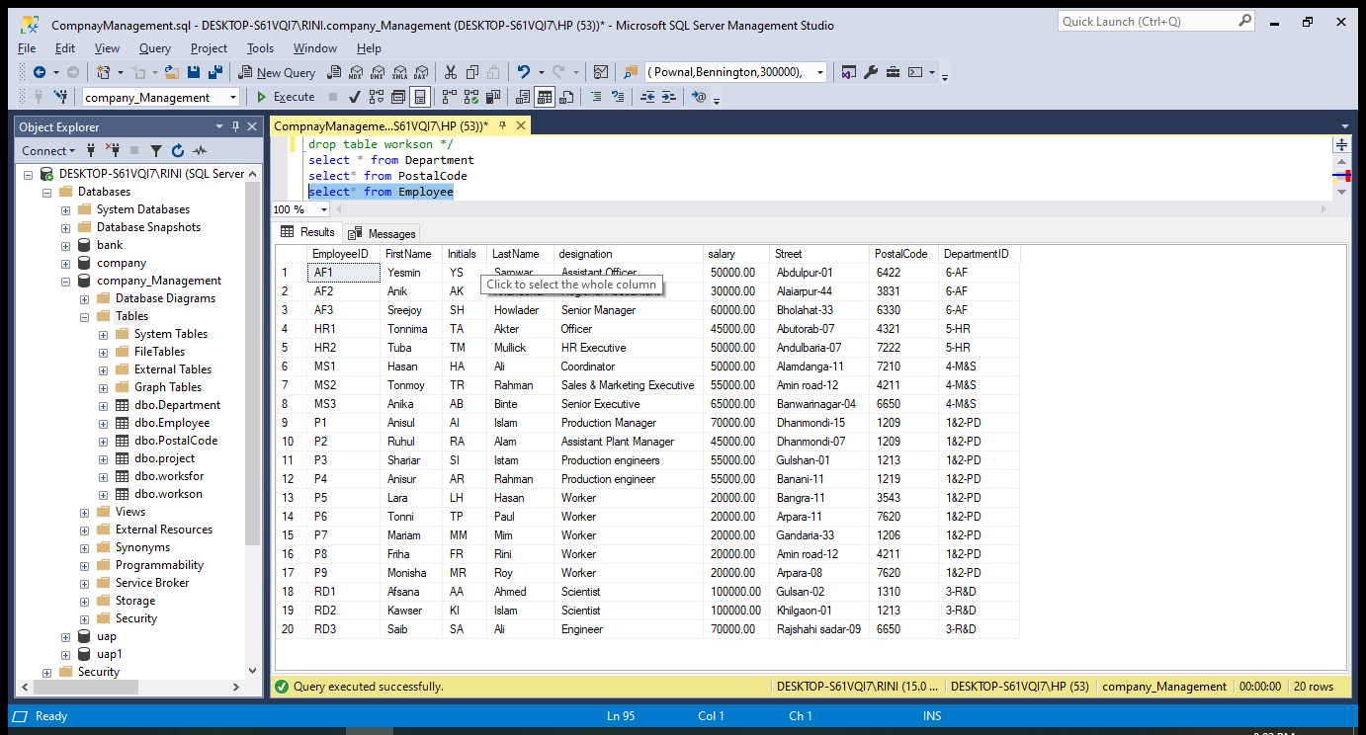

**select* from project**

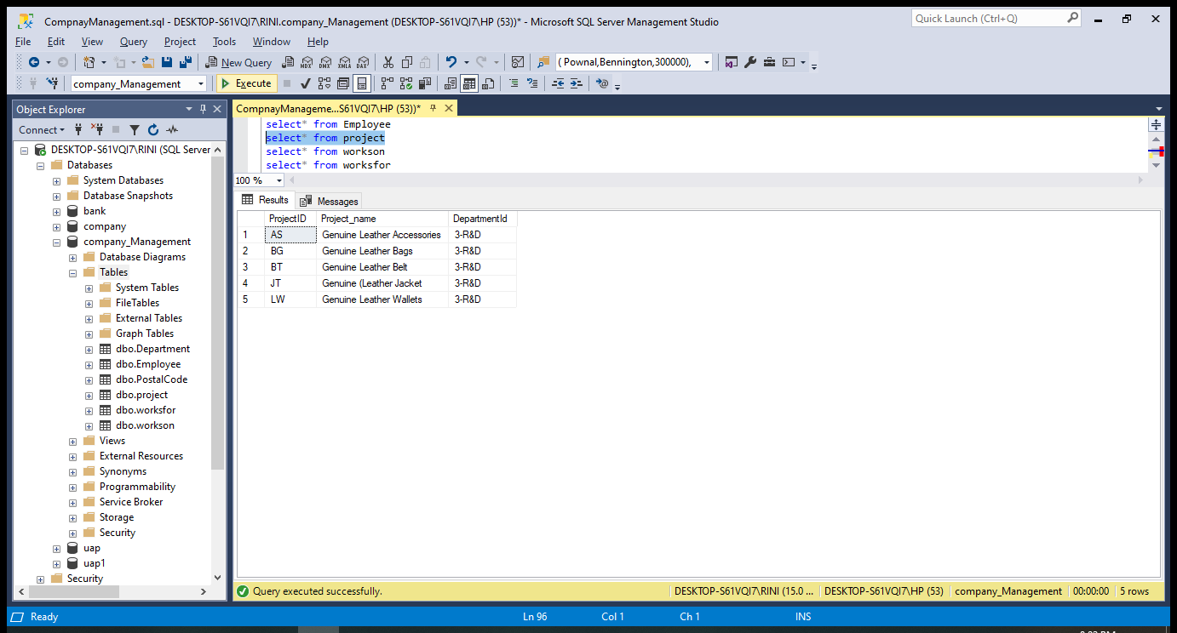

Page no: 14

**select* from workson**

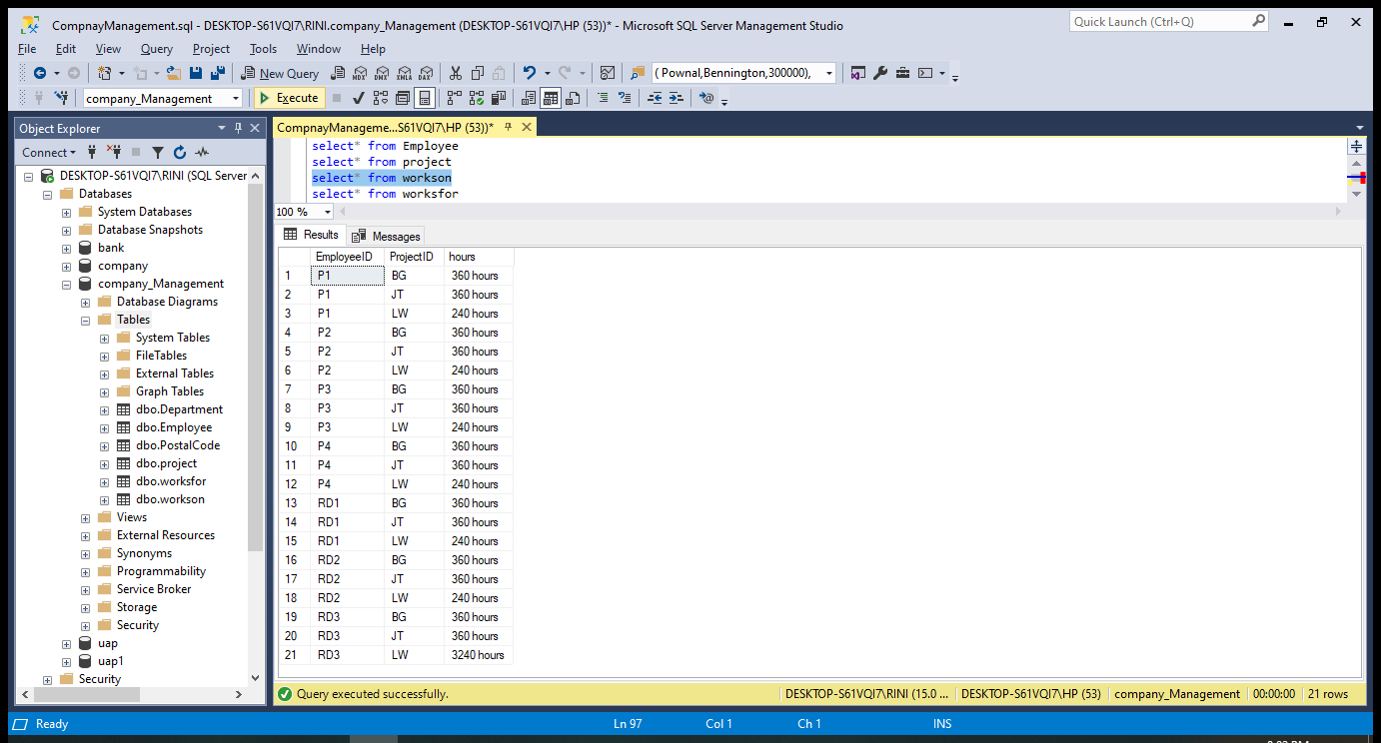

**select* from worksfor**

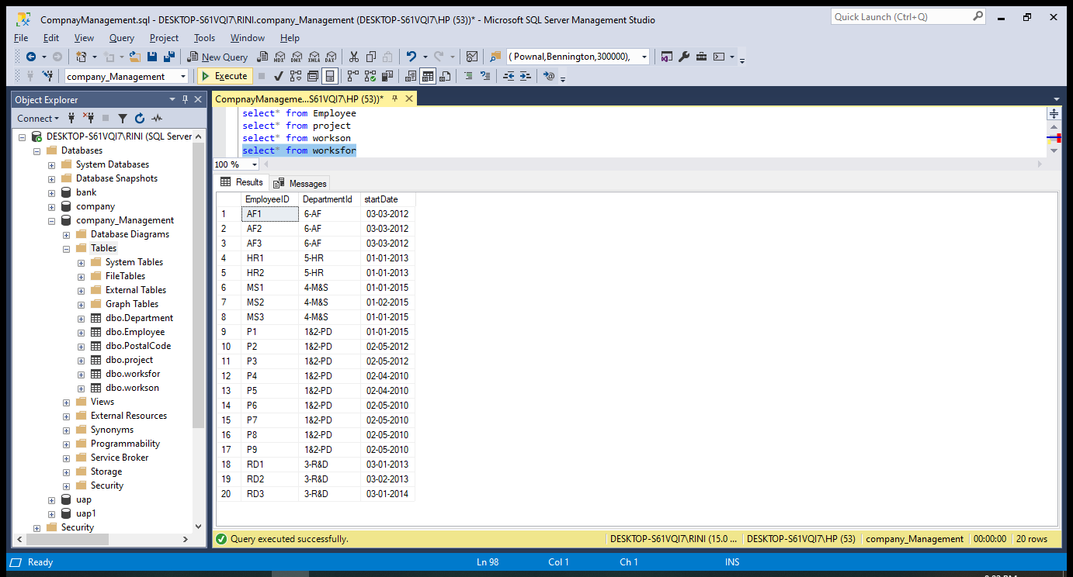

**Query**

Page no: 15

**1. Show all employee information where department ID=** '1&2-PD'

select * from employee where DepartmentID='1&2-PD'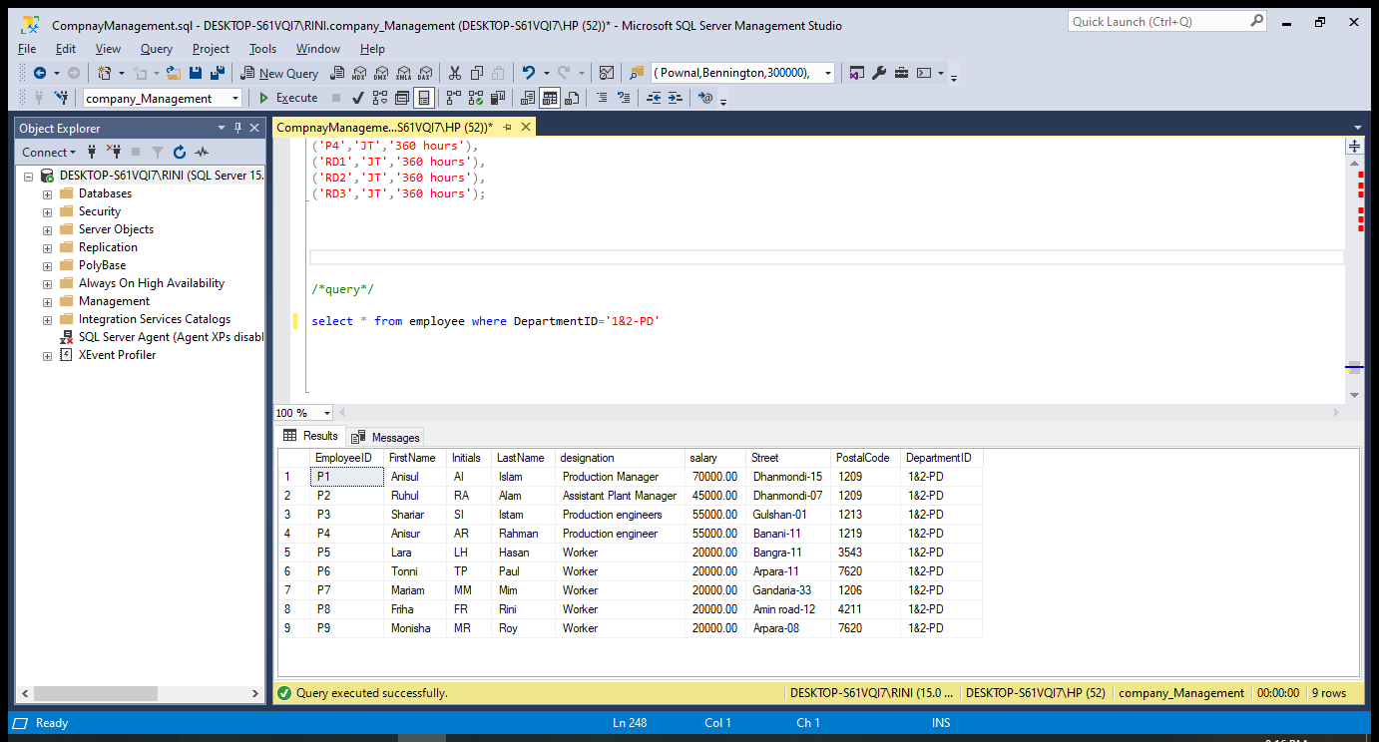

Page no: 16

**2. Show employed id, designation where department id=’5-HR’ or ‘6-AF’**

select EmployeeID,designation from employee where DepartmentID='5-HR'

union

select EmployeeID,designation from employee where DepartmentID='6-AF'

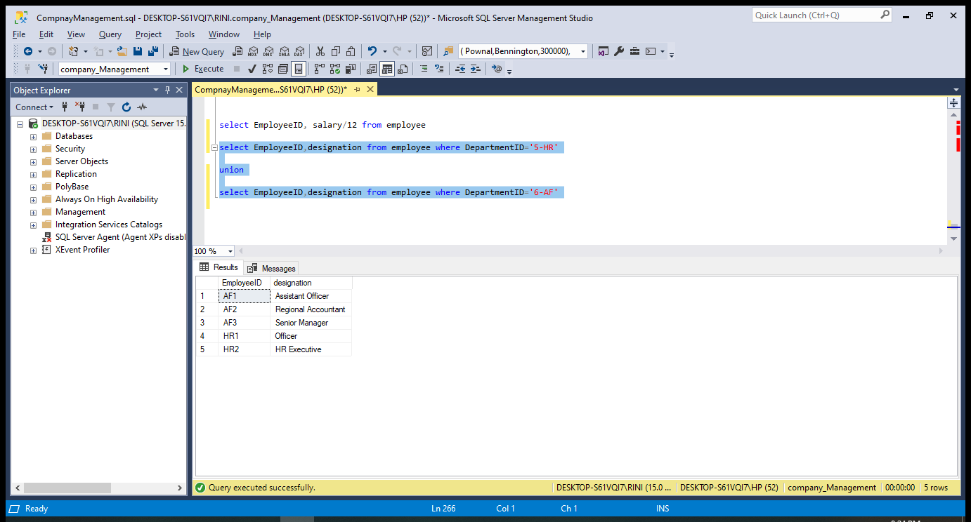

Page no: 17

**3. Show employed id, monthly salary**

select EmployeeID, salary/12 from employee

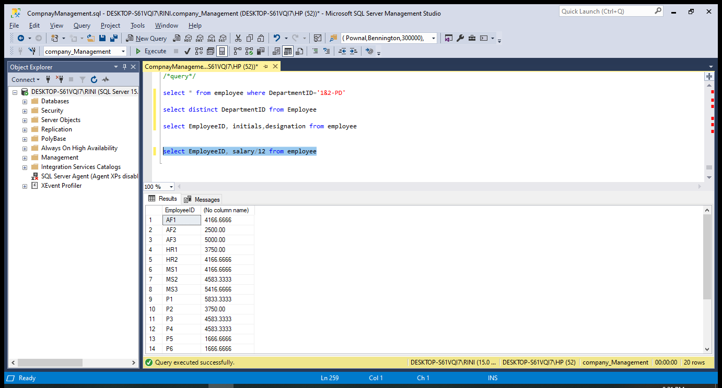

Page no: 18

**4. Show employed id who works on a project less than 360 hours**

select EmployeeID from workson where hours<'360 hours';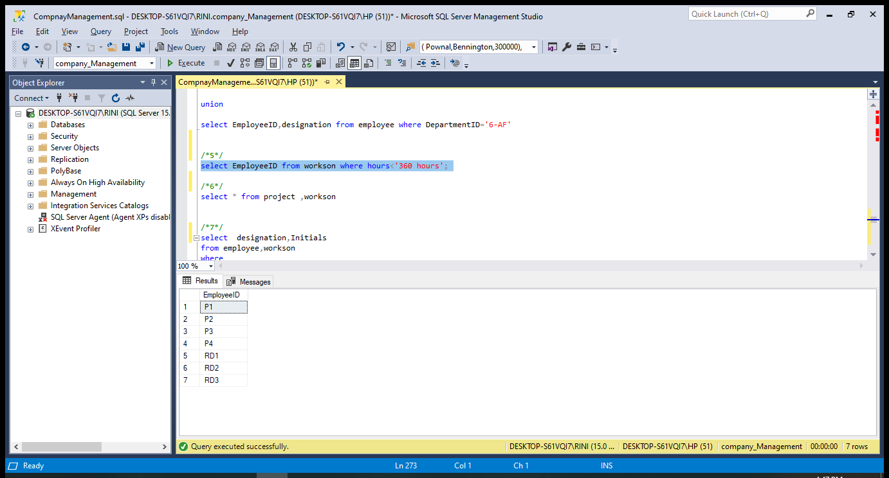

**5. Show designation, initials of those employees who involved in project ‘BG’ and who have salary more than 900000**

Page no: 19

select designation,Initials

from employee,workson

where

workson.EmployeeID=employee.EmployeeID

and

workson.ProjectID='BG' and salary >90000;

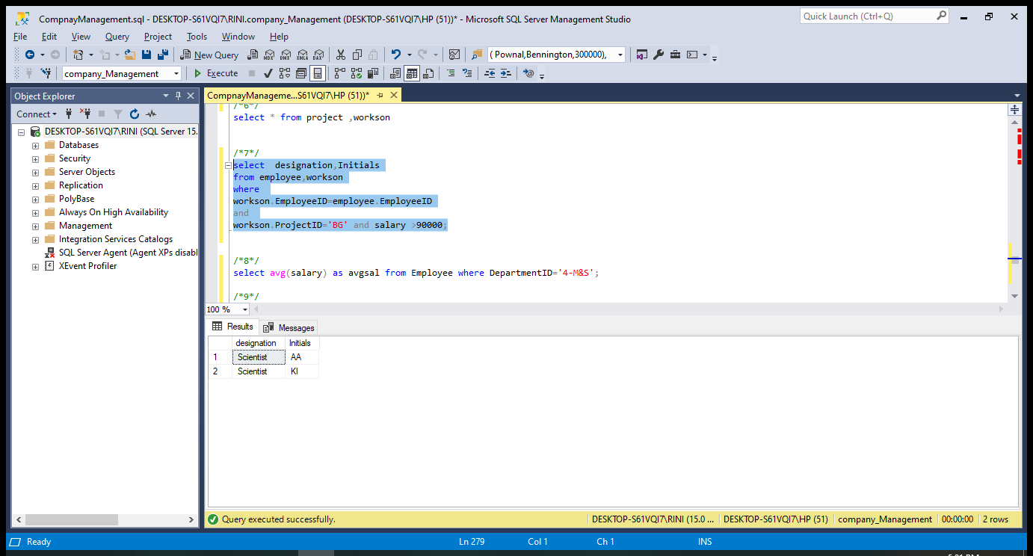

Page no: 20

**6. Show average salary of department id=’4-M&S’**

select avg(salary) as avgsal from Employee where DepartmentID='4-M&S';

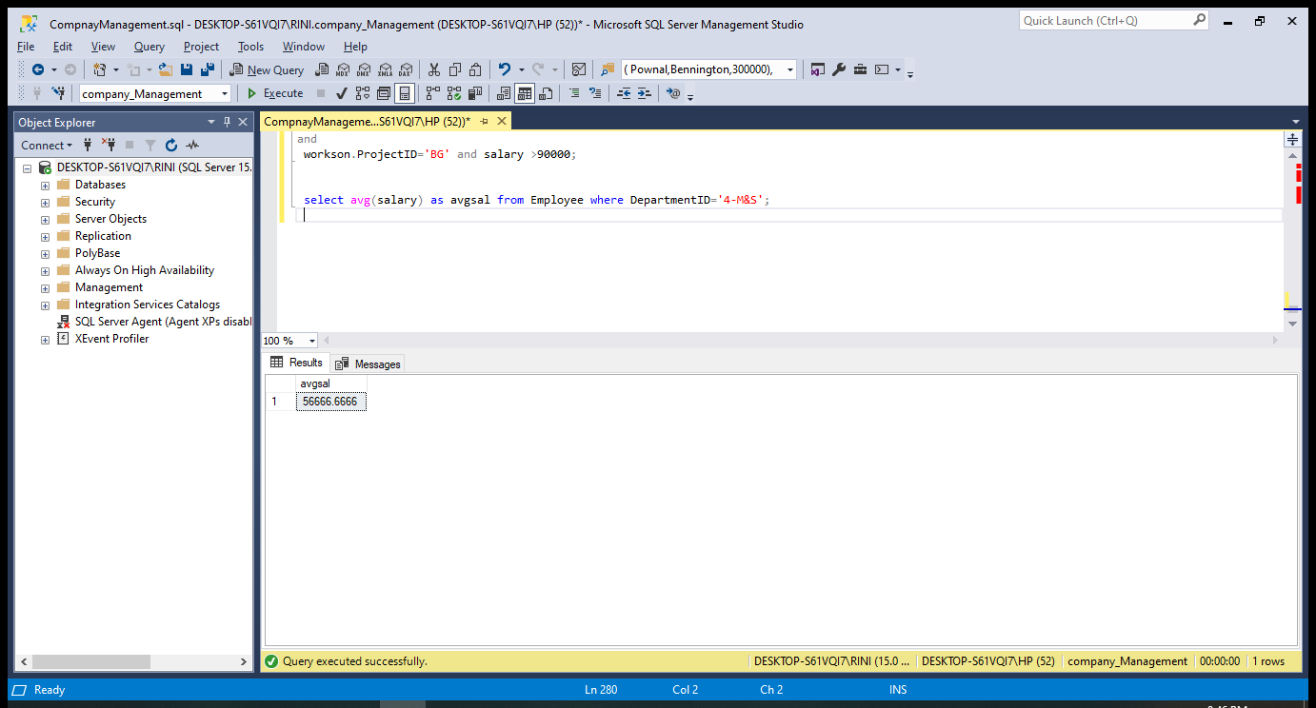

Page no: 21

**7. Show average salary of every department having average salary more than 30000**

select Departmentid , avg(salary) as avgsal from Employee group by DepartmentID having avg(salary)>30000

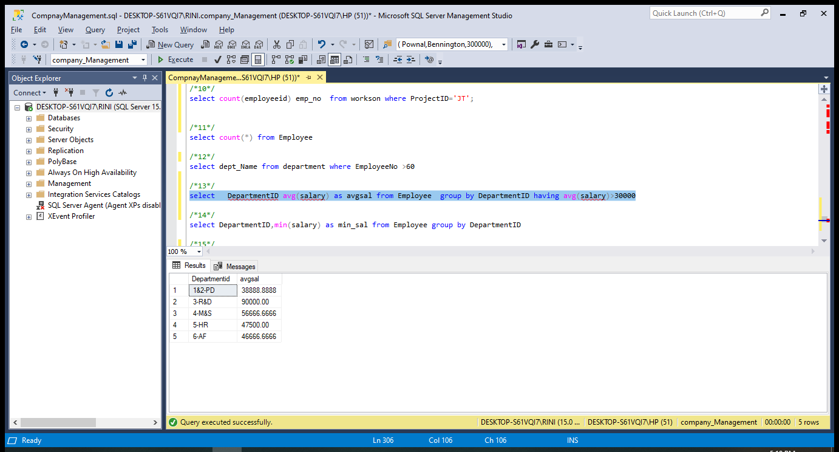

Page no: 22

**8. Update salary 25000 where salaries are =20000**

update employee set salary =25000

where salary =20000

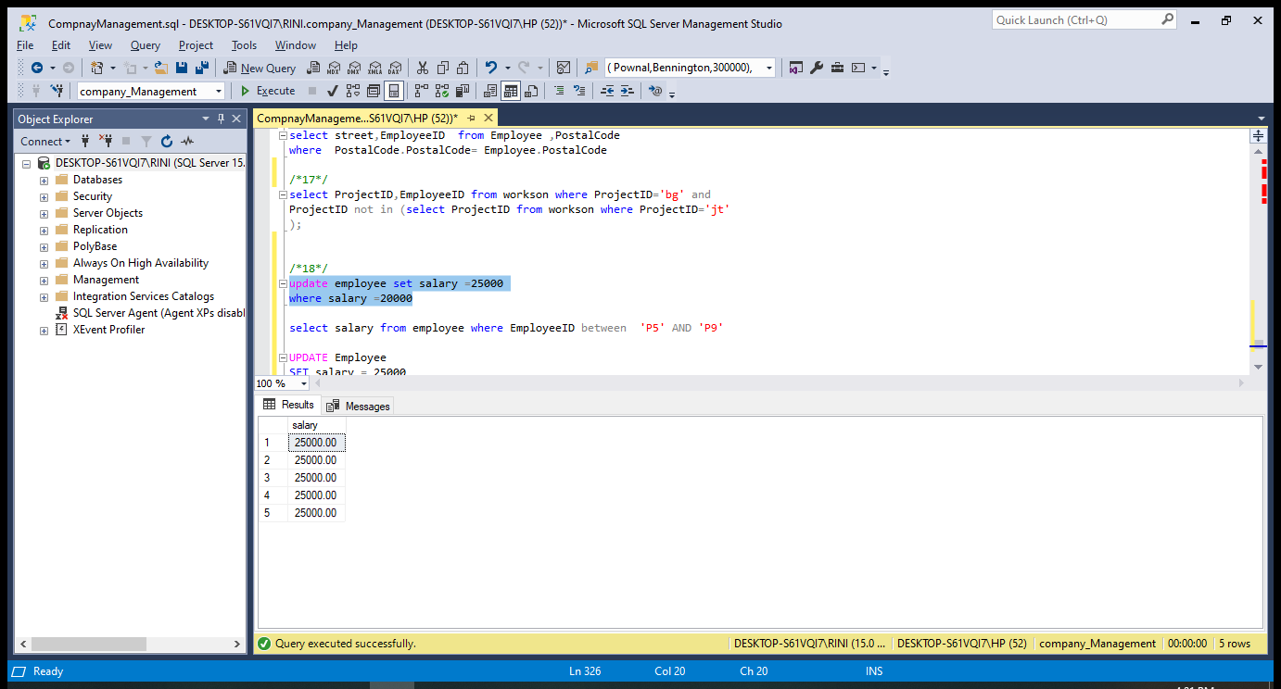

Page no: 23

**9. Show salary where employee id between ‘p5’ and ‘p6’**

select salary from employee where EmployeeID between 'P5' AND 'P9'

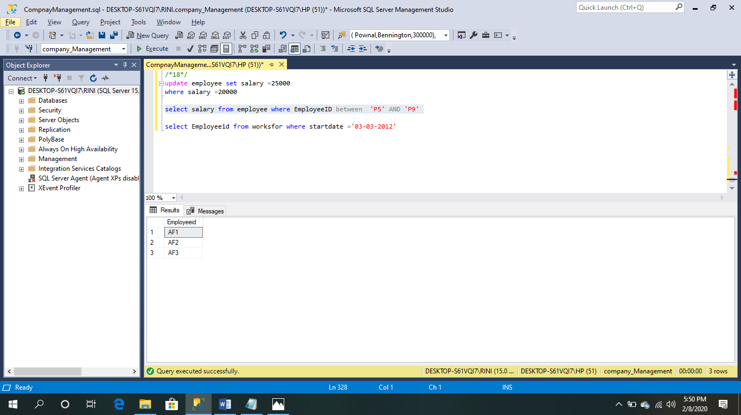

Page no: 24

**10. Show project id ,employee id who works on a project ‘BG’ and not in ‘JT’**

select ProjectID,EmployeeID from workson where ProjectID='bg' and

ProjectID not in (select ProjectID from workson where ProjectID='jt'

);

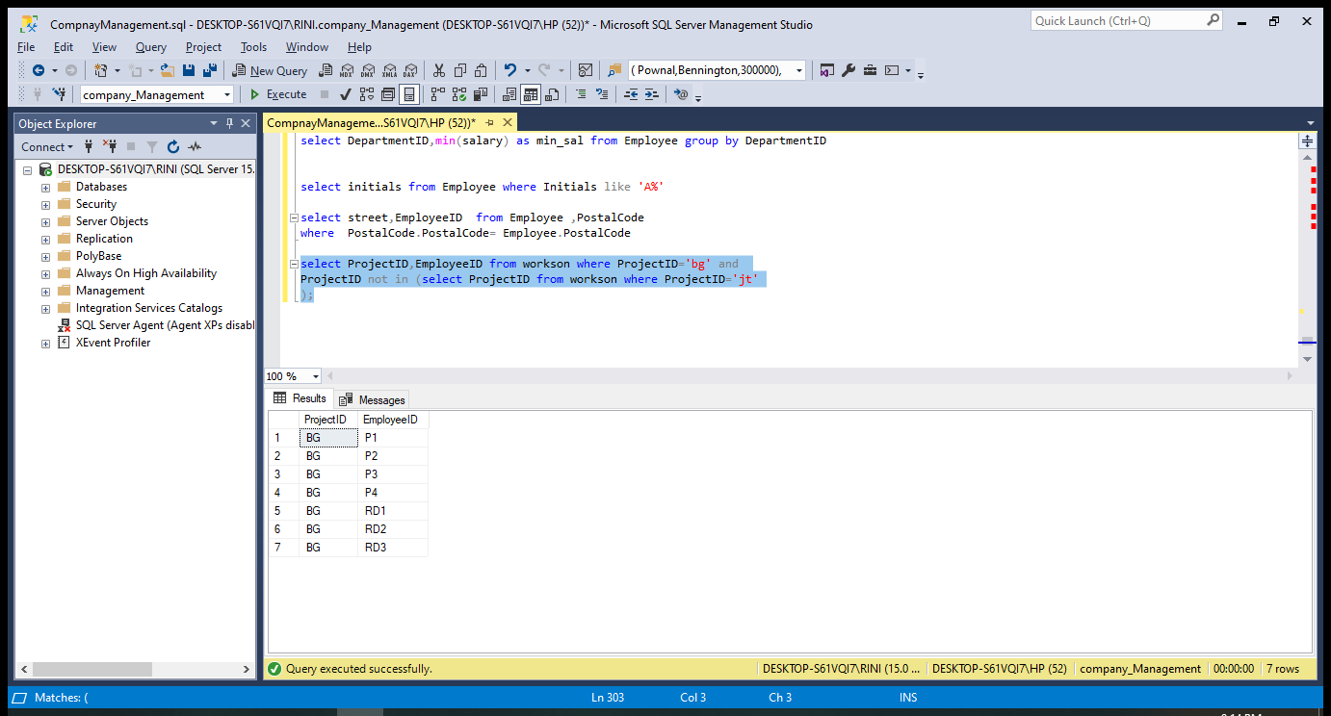

Page no: 25

**11. Show initials which start with an ‘A’**

select initials from Employee where Initials like 'A%'

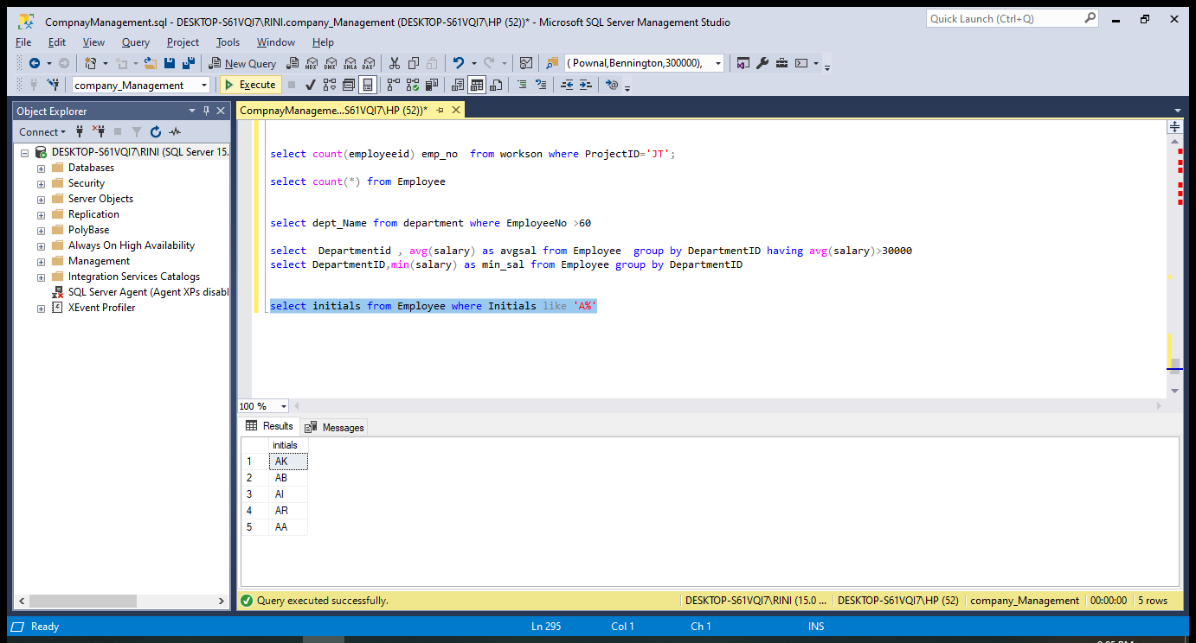

Page no: 26

**12. Show employee id who’s start date is** ='03-03-2012'

select Employeeid from worksfor where startdate ='03-03-2012'

